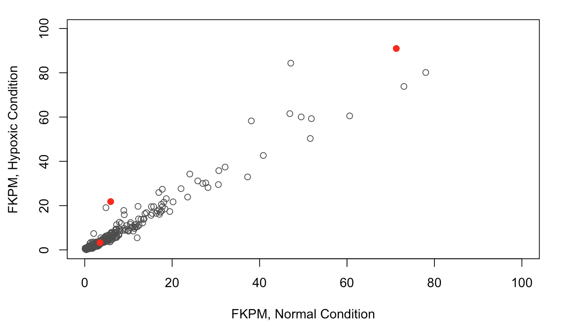

The gene family I chose was HK, hexokinase. The results of plotting this gene family suggest that hexokinase is expressed more under hypoxic conditions than normal conditions, since the HK points lie above the identity line (with the exception of the red point that is very close to 0 in both measurements). This seems to be corroborated by a 2005 paper, "*Overexpression of hexokinase protects hypoxic and diabetic cardiomyocytes by increasing ATP generation*" (www.ncbi.nlm.nih.gov/pubmed/16244374). Since hexokinase is involved in the phosphorylation of glucose in glycolysis, the additional hexokinase expression may be a mechanism to mitigate the effects of hypoxia on cellular respiration by increasing glycolysis for ATP generation.